Chris Evans

C00071997@setu.ie

web & cloud applications

Assignment 1

Create a Student Course Registration using PHP

Table of Contents

Introduction: 2

AI usage 2

Student Course Registration Portal Purpose and Operation: 3

Storyboard of the Application: 4

Database Tables Used: 5

Administrators Structure Table 5

Administrators Browse Table 5

Course Structure Table 6

Course Browse Table 6

Registration Structure Table 7

Registration Browse Table 7

Student Structure Table 8

Student Browse Table 8

Description of web pages: 9

Index.php 9

Student Menu’s 10

student_login.php 10

Student_register.php 12

Student_menu.php 13

Student_register_course.php 14

student_view_my_course.php 16

student_drop_course.php 17

student_profile.php 18

Administration Menu’s: 19

admin_login.php 19

admin_menu.php 20

admin_add_course.php 21

admin_approve_registration.php 24

admin_view_registration.php 26

admin_student_view.php 27

Logout.php 29

db.php 29

## Introduction:

This assignment explores the development of a dynamic Student Course Registration Portal using PHP and MySQL, designed to streamline academic workflows for both students and administrators. The portal enables students to register for courses, view and manage their enrolment’s, edit personal profiles, and drop courses—all through a secure, user-friendly interface. Administrators, on the other hand, can manage course offerings, approve or remove student registrations, and oversee student data. The system is built with modularity and clarity in mind, ensuring each user role has access to relevant features while maintaining data integrity and operational efficiency.

The project emphasizes practical implementation of web and cloud application principles, including session management, database interaction, and form handling. It also demonstrates the use of structured navigation through a storyboard, guiding users from login to task completion with intuitive page flows. By combining backend logic with responsive front-end design, the portal reflects a real-world application of PHP in educational environments. This document outlines the system’s purpose, architecture, database schema, and individual page functionalities, offering a comprehensive view of its design and operation.

##### AI usage

The use of AI, I used to write all the base php code for each of the functions. This was then adapted to work with my data base inputs and my CSS and any other things that were added later added later.

The Database no AI was used to set up, and the CSS was adapted from a previous project and again was added to, and other items were deleted.

## Student Course Registration Portal Purpose and Operation:

The purpose of the Student Course Registration Portal is to provide a secure and efficient platform for students to manage their academic course enrolment’s and for administrators to oversee and maintain course-related data. It streamlines the registration process by allowing students to log in, register for available courses, view their current enrolment’s, edit personal details, and drop courses when necessary—all through an intuitive web interface.

From the administrative side, the portal enables authorized staff to add and update course offerings, approve or remove student registrations, and view student information. The system ensures role-based access, maintains data integrity, and supports real-time updates to the database. By combining backend logic with a modular front-end design, the portal enhances usability and reflects practical web development principles using PHP and MySQL.

## Storyboard of the Application:

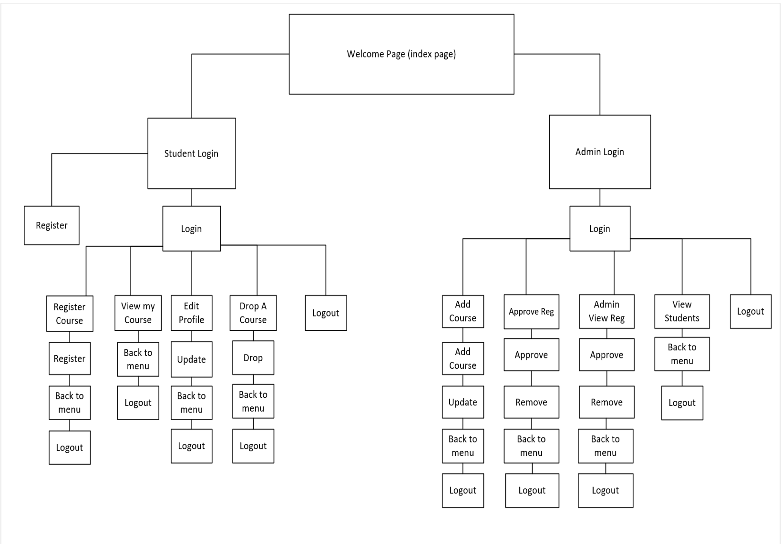

This storyboard maps out the full navigation flow of a student and admin portal starting from a shared Welcome Page. Students log in to access features like course registration, viewing enrolled courses, editing their profile, and dropping courses—with each action offering options to return to the menu or log out. Admins follow a parallel path, logging in to manage courses, approve or remove registrations, and view student details. Each admin function also includes navigation back to the menu or logout, ensuring consistent user experience. The structure is modular, with clear separation between student and admin roles, and each node leads logically to its next step. Overall, it’s a well-organized blueprint for a user-friendly educational management system.

## A screenshot of a computer AI-generated content may be incorrect.Database Tables Used:

##### Administrators Structure Table

##### A screenshot of a computerAdministrators Browse Table

##### A screenshot of a computer Course Structure Table

##### A screenshot of a computer AI-generated content may be incorrect.Course Browse Table

##### A screenshot of a computer AI-generated content may be incorrect.A screenshot of a computerRegistration Structure Table

##### Registration Browse Table

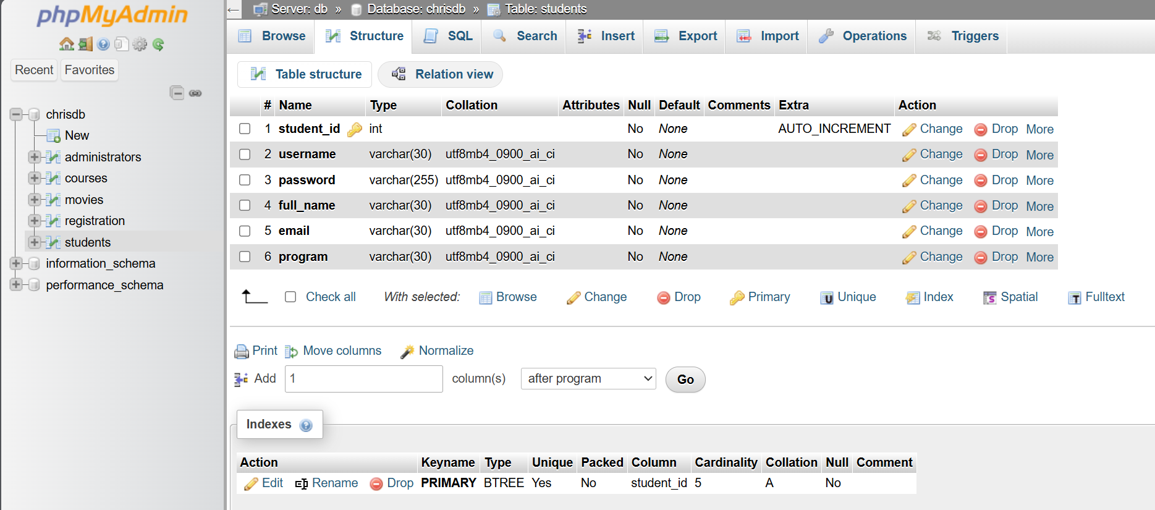

##### A screenshot of a computer AI-generated content may be incorrect.Student Structure Table

##### Student Browse Table

## Description of web pages:

##### A screenshot of a green and red login pageIndex.php

This is the main screen and welcome you to the main menu, from here you have 2 options.

* Student Login
* Administrator Login
* 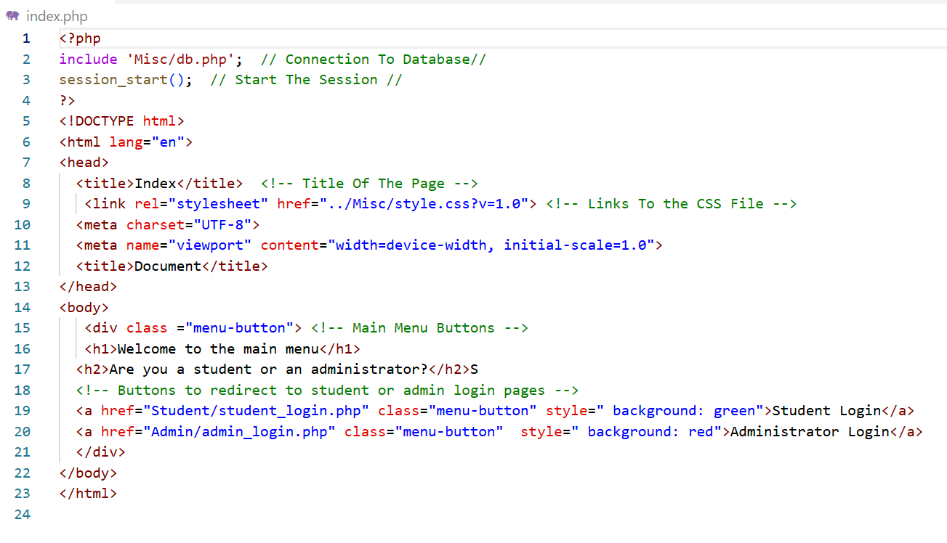These will bring you o the main menu of each role.

## Student Menu’s

##### student_login.php

This screen gives you 2 options, if registered you can proceed straight to the login menu, if not there is an option to register as a new student ( this will be shown on the following slide).

* Login
* Register

Login will take to the student’s main menu.

Register allows you to enter your details which will be entered into the database.

Then you can proceed with the login option.

##### A screenshot of a computer AI-generated content may be incorrect.Student_register.php

Enter all your details and select register button , from there you now be able to login as a student.

You can also go back to the main page or logout.

##### A screenshot of a cell phoneStudent_menu.php

This now give a range of option, to register a course, view your courses, drop a course, edit you profile and logout. Just select the option required and this will take you to that option.

Over the next few slides, we will look at the individual options.

##### A screenshot of a computer Student_register_course.php

This screen allows you to register a new course by selecting the dropdown menu and selecting the course you desire and then by selecting the register button, this will place the course into pending awaiting the administer to approve or deny.

You also have the option to go back to the main menu or logout.

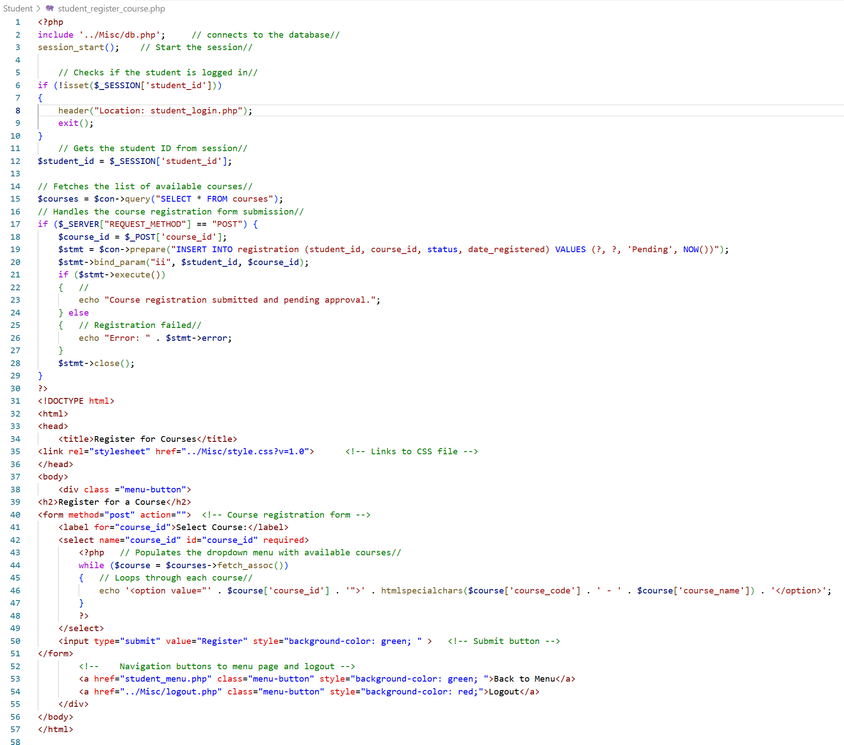

##### A screenshot of a computer student_view_my_course.php

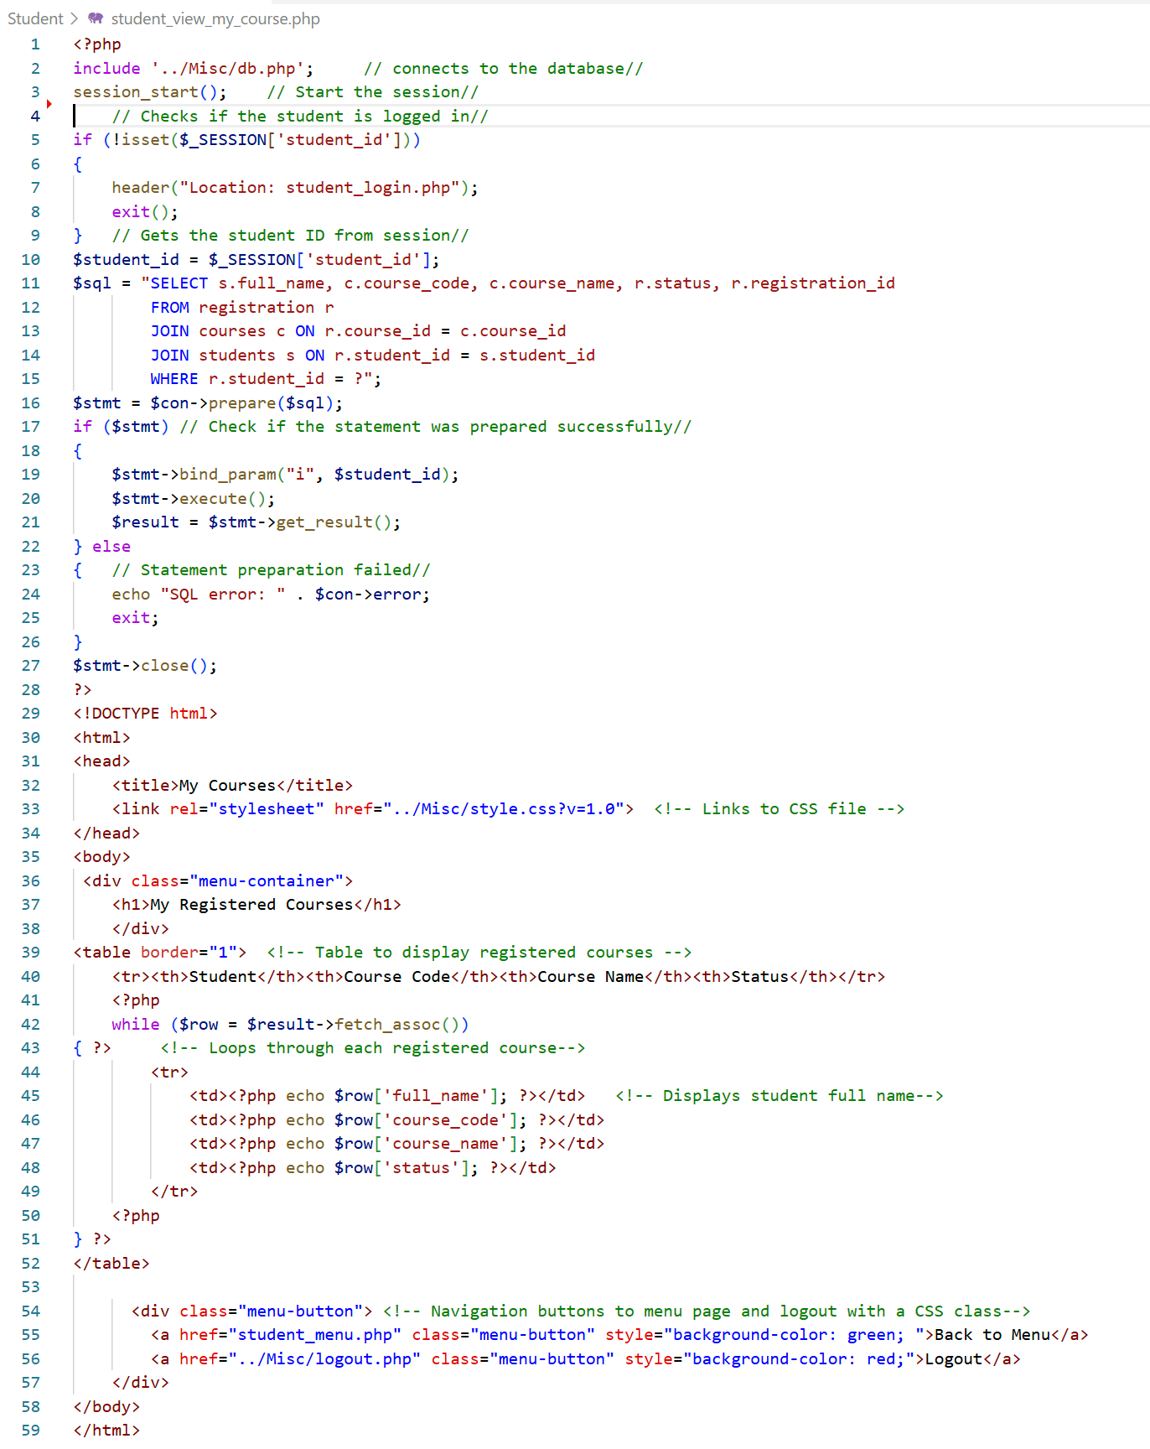This allows me to view the courses that I have registered and show whether they have been approved by the administrator of is still pending.

##### student_drop_course.php

This screen displays the courses that you are registered for and give you the option to drop the course by selecting the drop button, once selected the course will disappear.

You also have the back to menu and the option to logout.

##### student_profile.php

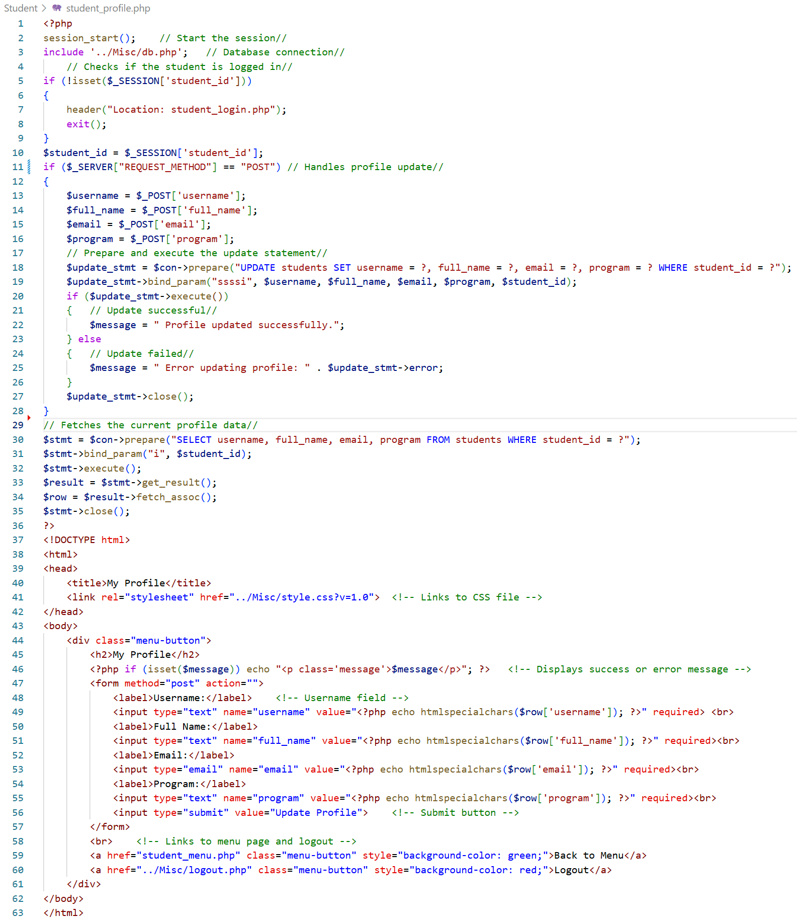This screen allows you to view your profile with the option to edit it if you wish to by be changing the content in any box and selecting the update button. This will automatically change you content in the database. You also have the back to menu and log out option.

## Administration Menu’s:

##### admin_login.php

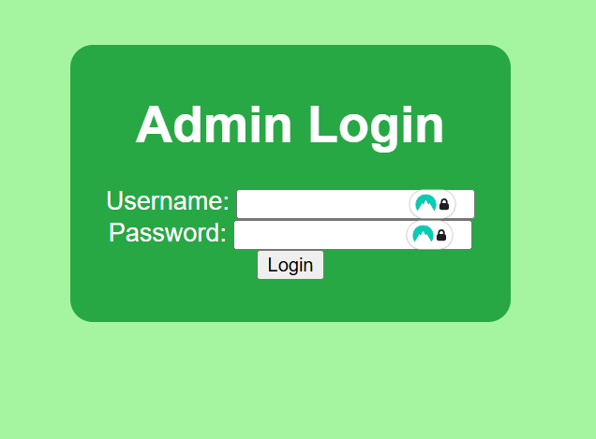

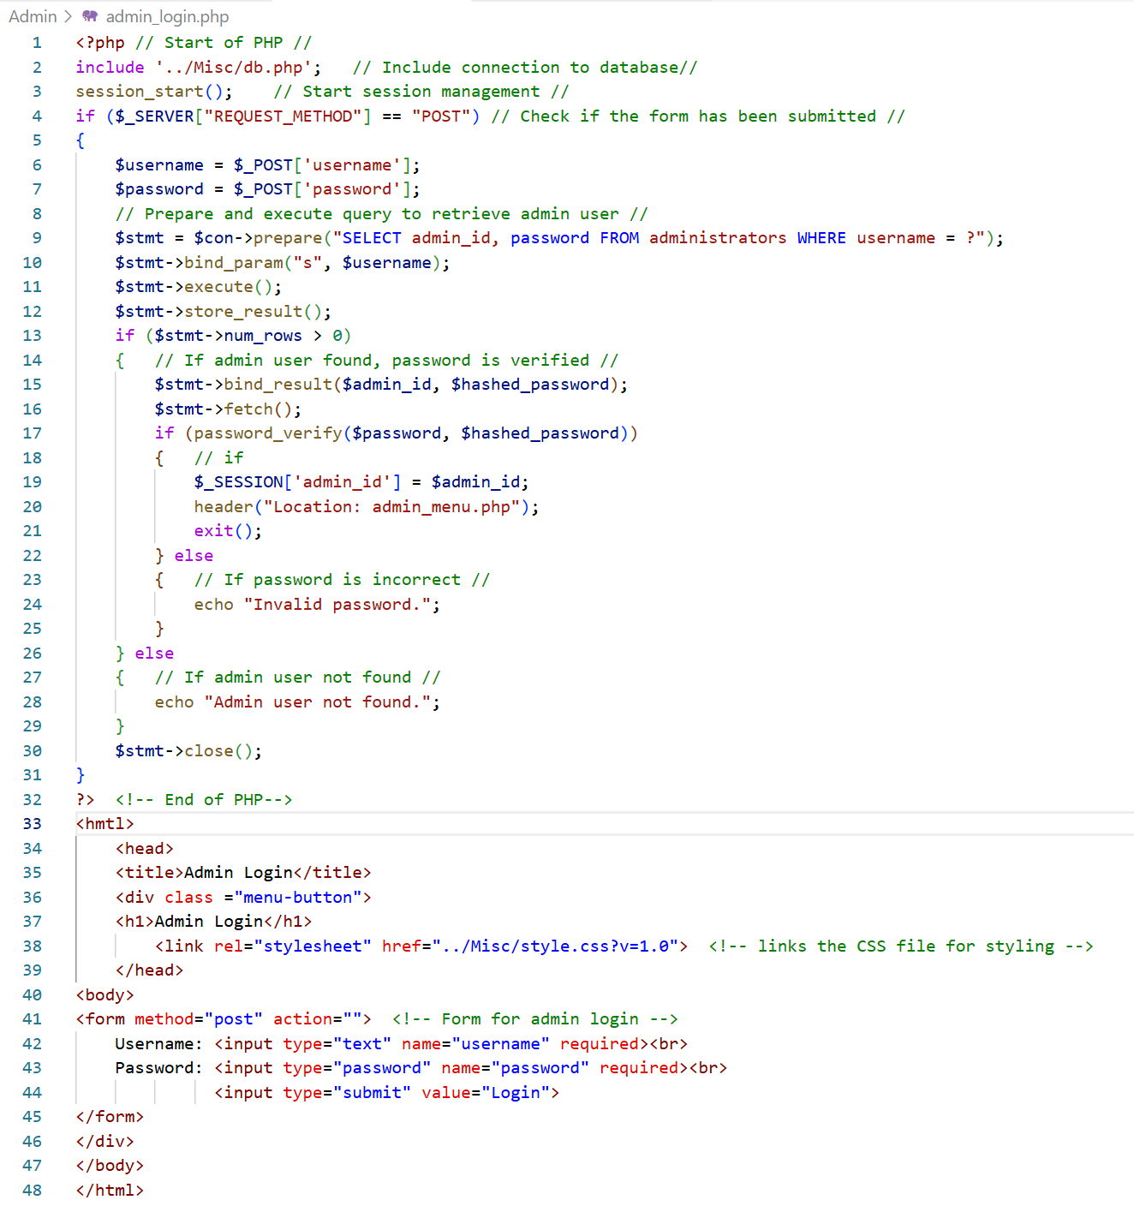This screen allows a registered administrator to login to the menu.

##### A screenshot of a computer AI-generated content may be incorrect.admin_menu.php

This menu gives you multiple options (Add course, Approve ,Amend and view registration, it also allows you to view all the students registered. Just by selecting one of the buttons it will take you to that screen. And you have the option to logout if you need to.

##### admin_add_course.php

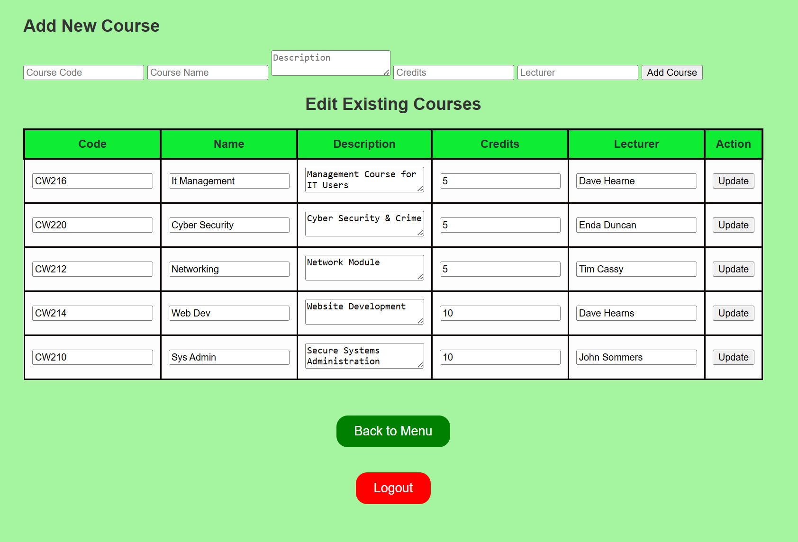

This screen at the top allows you to add a new course, by inputting details into the appropriate boxes and select add course, it also allows you to edit existing courses by amending the detail already in the current boxes and then by selecting the update button. And you have the usual back to menu and log out feature.

##### admin_approve_registration.php

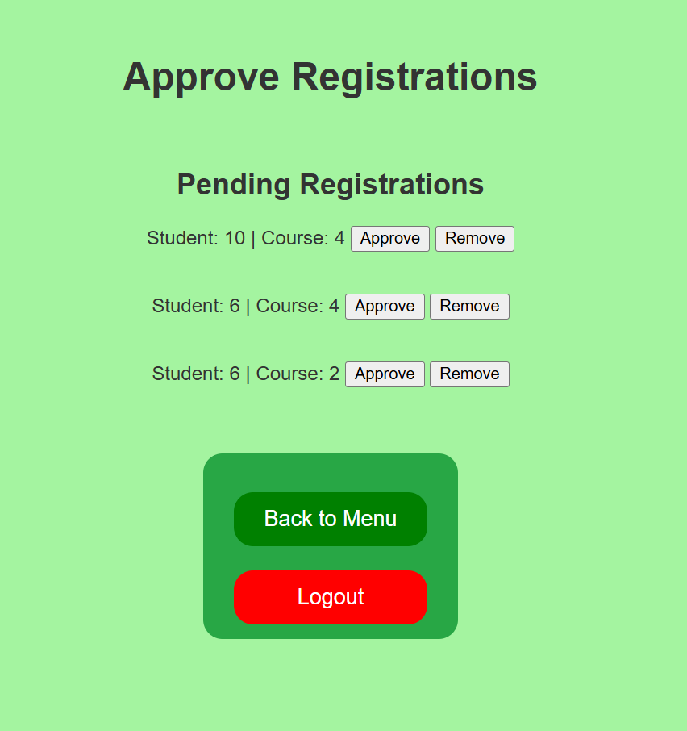

This screen shows the courses that are awaiting to be approved by one or more students, the administrator has the option to approve the course or remove the course thus not allowing the student the option to continue to that course. This is done by just selecting the approve or the remove button.

You also have the back to menu, and the logout option should you need them.

##### A screenshot of a computeradmin_view_registration.php

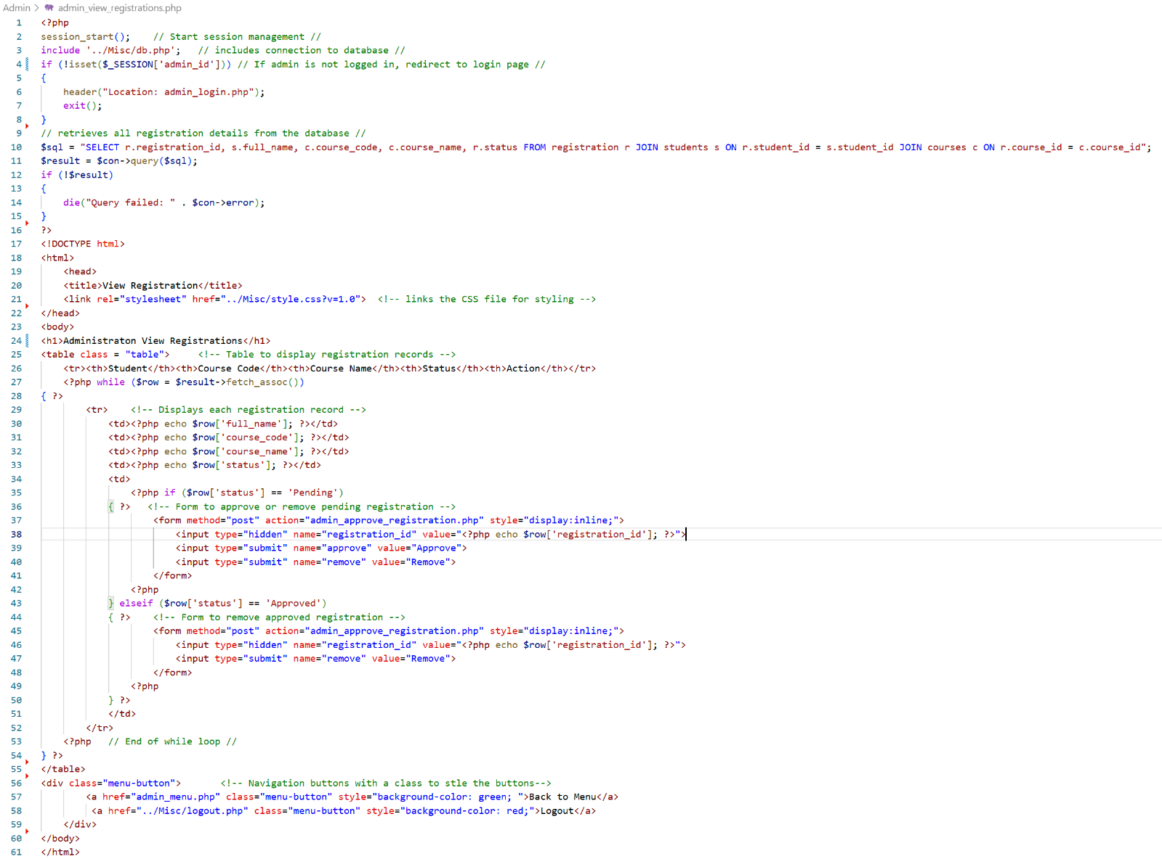This screen allows you to view all registered courses but also gives the option to approve or remove a student’s course. With the back to menu and logout option.

##### A screenshot of a computeradmin_student_view.php

This screen shows all the students details with the course they are on and email details. This is only for viewing and can not be amended from here.

And the usual back to menu and logout button are an option if needed.

##### A screenshot of a computer code AI-generated content may be incorrect.Logout.php

This is the code that give the logout option on most of the screens.

##### A screen shot of a computer code AI-generated content may be incorrect.db.php

This is what connects the code to the database.